CSC ESA
GROUND SEGMENT OPERATIONS FRAMEWORK
OPERATIONS COORDINATION DESK SERVICE

[OMCS] Configuration Tool End User Manual

Title: | CSC Coordination Desk – [OMCS] Configuration Tool End User Manual
Abstract: | This document represents the End User Manual of the Configuration Tool
Author: | CD Dev Team | Verified: | Andrea Bolle
 | CSC Coordination Desk Dev Team |  | CSC Coordination Desk Service Manager
Approved: | Andrea Bolle | Authorised: | Roberto Zaccari
 | CSC Coordination Desk Service Manager |  | Product Assurance Manager
Accepted by ESA:
Filename: | CSC Coordination Desk - [OMCS] Configuration Tool End User Manual.docx

Document Status Sheet
ISSUE | DATE | AUTHOR | VERIFIED | APPROVED | REASON OF THE MODIFICATION
1.0 | 25/07/2024 | CD Dev Team | A. Bolle | A. Bolle | First Issue

Document Change Record History
No | Change In Issue | Description of Change | Section | Change made by

Table of Content
1 Introduction 6
1.1 Purpose 6
1.2 Structure of the document 6
2 Applicable and Reference Documents, Acronyms 7
2.1 Applicable Documents 7
2.2 Reference Documents 7
2.3 Acronyms and Abbreviations 7
3 Configuration Tool Web Application 9

Index of Figures
Figure 3-1 The Configuration Tool Default Home page 9
Figure 3-3 The Interfaces web page 10
Figure 3-4 The Services web page 10
Figure 3-5 The Processors web page 11

Index of Tables
Table 1 Applicable Documents 7
Table 2 Reference Documents 7
Table 3 Acronyms and abbreviations 8

Introduction
The present document is delivered in the context of the OMCS branch of the CSC Coordination Desk Programme.

Purpose
The purpose of the present document is to describe the main pages and characteristics of the Configuration Tool.

Structure of the document
The present document is structured as follows:
- Chapter 1: Introduction – this Chapter;
- Chapter 2: Applicable and Reference documents, Acronyms
- Chapter 3: Configuration Tool Web Application

Applicable and Reference Documents, Acronyms

Applicable Documents
The following table lists the applicable documents.
Refer. | Title | Code
[AD-IL] | Invitation To Tender for ESA Ground Segment Operations Framework Operations Coordination Desk Service | AO/1-10177/12/I-BG-SC 13.05.2021
[AD-SOW] | Copernicus Space Component - ESA Ground Segment Operations Framework – Coordination Desk Service - STATEMENT OF WORK | ESA-EOPG-EOPGC-SOW-20 Issue 1.0
[AD-DC] | Appendix 2 to ITT – Draft Contract | 13.05.2021
[AD-STC] | Appendix 3 to ITT – Special Conditions of Tender | 13.05.2021
[AD-ADG] | Auxiliary Data Gathering Technical Requirements | ESA-EOPG-EOPGC-RS-17 Issue 1.0
[AD-WEB] | Web Pages Operations Technical Requirement | ESA-EOPG-EOPGC-RS-14 Issue 1.0
[AD-OMCS] | Operations Monitoring and Coordination Service Technical Requirements | ESA-EOPGEOPGC-RS-18 Issue 1.0
[AD-SLA] | SLA and Key Performance Indicators | EOPG-EOPGC-TN-43 Issue 1.0
[AD-SEC] | Coordination Desk Service - Security Requirements Document | ESA-EOPG-EOPGCS-SP-13 Issue 1.0
[AD-CDP] | CSC PDGS/CDS Coordination Desk Procedures | COPE-GSEG-EOPG-PR-14-0035 Issue 2.0
[AD-MNT] | CSC Ground Segment Coordinated Maintenance Procedure, | COPE-PMAN-EOPG-PR-14-0001 Issue 4.0
[AD-CM] | CSC Ground Segment Configuration Management Requirements, | ESA-EOPG-CSCOP-RS-14 Issue 1.0
[AD-AMP] | CSC Ground Segment Anomaly Management Procedure, | GMES-GSEG-EOPG-PR-13-0008 Issue 4.0
[AD-CIDL] | CSC Coordination Desk – Configuration Data Item List | ESA-EOPG-EOPGC-TN-45 Issue 1.0
Table 1 Applicable Documents

Reference Documents
The following table lists the reference documents.
Refer. | Title | Code
[RD-ARCH] | CSC Operations – ESA Framework – Ground Segment Architecture, | ESA-EOPG-EOPGC-TN-7 Issue 1.2
[RD-MICD] | Copernicus Space Component ESA Ground Segment Operations Framework-MasterICD | ESA-EOPG-EOPGC-IF-6 Issue 1.2
[RD-CSDAR] | Copernicus Sentinel Data Access Report https://scihub.copernicus.eu/twiki/pub/SciHubWebPortal/AnnualReport2019/COPESERCO-  RP-20-0570_-_Sentinel_Data_Access_Annual_Report_Y2019_v1.0.pdf
[RD-EUG] | EU green public procurement criteria for data centres, server rooms and cloud services | SWD(2020) 55 final
[RD-NRJ] | Acton, M., Bertoldi, P., Booth, J., Flucker, S., Newcombe, L., Royer, A. and Tozer, R., 2019 Best Practice Guidelines for the EU Code of Conduct on Data Centre Energy Efficiency, European Commission, Ispra, 2018, | JRC114148
[RD-GL] | CSC Sentinel Ground Segment Operations Glossary | ESA-EOPG-EOPGC-TN-13
[RD-STB] | System Technical Budget | ESA-EOPG-EOPGC-TN-09 Issue 1.4
Table 2 Reference Documents

Acronyms and Abbreviations
The following table contains all acronyms and abbreviations used in the current document.
Acronym/Abbreviation | Definition
API | Application Programming Interface
AUX | Auxiliary
AUXIP | Auxiliary Interface (delivery) Point
CADU | Channel Access Data Unit
Cal/Val | Calibration/Validation
CCD | Copernicus Coordination Desk
CFI | Customer Furnished Item
COM | European Commission
CSC | Copernicus Space Component
CVIP | Calibration & Validation Interface (delivery) Point
DD | Data Distribution
DP | Documentation Package
DPA | Dynamic Procurement Approach
E2E | End-to-End
EC | European Commission
ECMWF | European Centre for Medium-Range Weather Forecasts
EDRS | European Data Relay Satellite System
EO | Earth Observation
EOF | ESA Operations Framework
EOP | Earth Observation Programme
ESA | European Space Agency
EU | European Union
EUM | EUMETSAT
FC | Frame Contract
FTP | File Transfer Protocol
GS | Ground Segment
HKTM | Housekeeping Telemetry
ICD | Interface Control Document
IF | Interface
IP | Interface (delivery) Point
IPF | Instrument Processing Facility
ITT | Invitation To Tender
KPI | Key Performance Indicators
LTA | Long Term Archive
MP | Mission Planning
MPIP | Mission Planning Interface (delivery) Point
ODP | On-Demand Processing
ODPRIP | On-Demand Processing Interface (delivery) Point
Table 3 Acronyms and abbreviations

Configuration Tool Web Application
The Configuration Tool is a web application promoted by the European Space Agency in the framework of the Coordination Desk Programme.
This web application is meant to collect the detailed information about the Copernicus Sentinels Ground Segment configuration, the service providers, the interfaces and the processors releases by each production service.
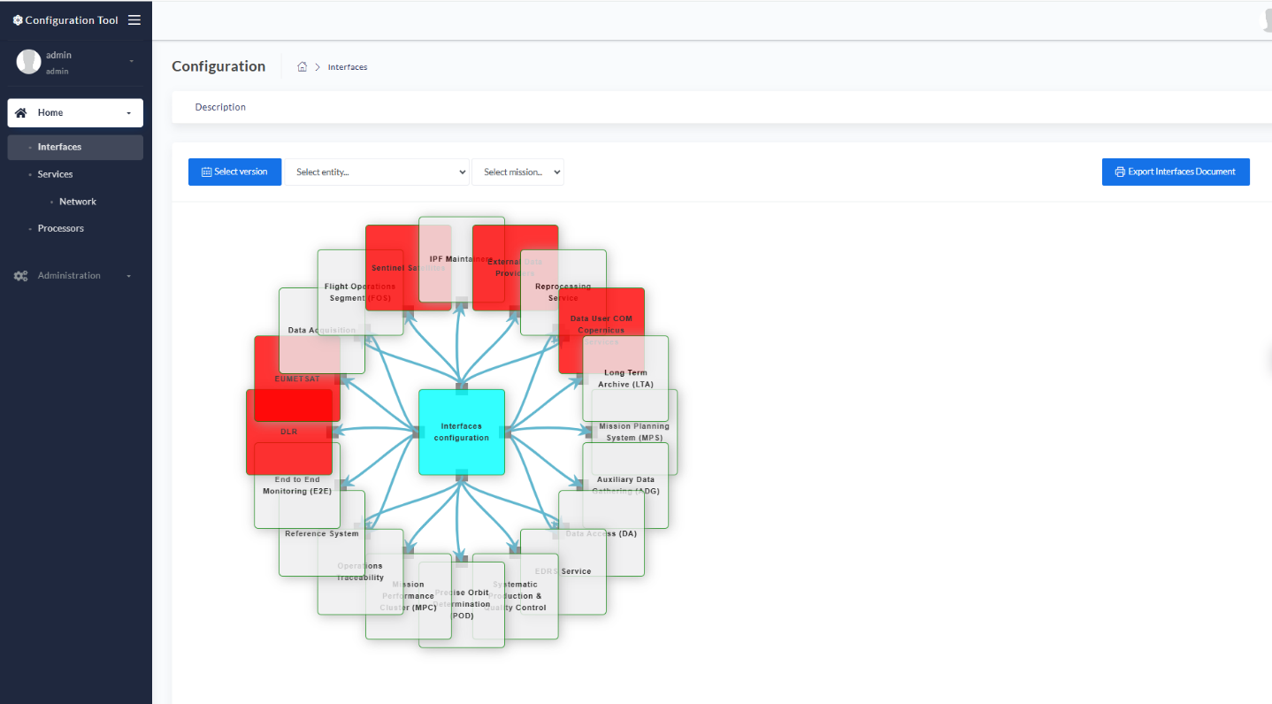
Figure 3-1 The Configuration Tool Default Home page
More in details, the Configuration Tool offers the following views:
- the Interfaces page, with the detailed view of the external and internal interfaces of every component of the Copernicus Ground Segment
- the Services page, meant to collect information about every interface implementation by each Service Provider. This page is enriched also with a Network sub-page, with the IP addresses and the clients whitelisted by each cloud provider
- The Processors’ Releases web page, showing the history of the releases of the processors for all missions, together with the processor’s validity and the reason behind the release
The Interfaces page reports a detailed view of the external and internal interfaces of every component of the Copernicus Ground Segment. Users can filter the relevant interfaces by:
- Service, using the dedicated dropdown menu
- Satellite, using the dedicated dropdown menu
By choosing a Service, the interface diagram will be centred around that service, showing the in/out connections. By clicking on an interface name, some information about the selected interface will be displayed. Satellite and Service filters work in parallel: users can select a Service and then narrow the displayed connections by selecting the mission of interest.
This view offers the capability of loading past committed versions of the interface diagrams, by clicking on button located at the left-hand side of the header bar.
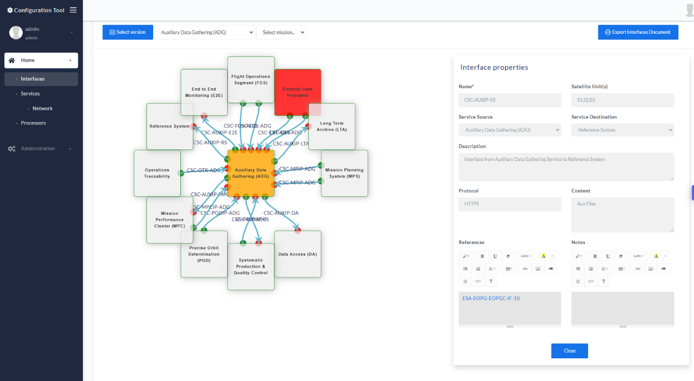
Figure 3-2 The Interfaces web page
The Services page is meant to collect information about every interface implementation by each Service Provider. In the Services page, operational I/Fs are displayed in green; blue is used to mark I/Fs that will be implemented in the future. Even in this case, it is possible to filter both the Services and the relevant connection by satellite.
The Services page is also enriched with a Network sub-page, with the IP addresses and the clients whitelisted by each cloud provider.
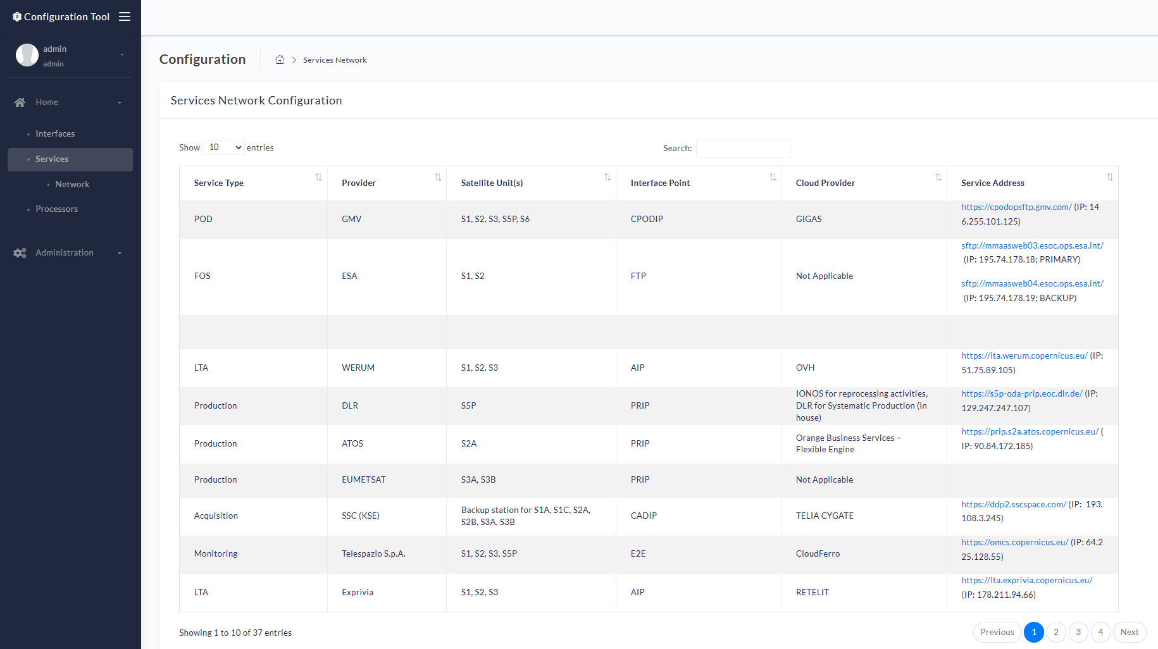
Figure 3-3 The Services web page
The Processors’ Releases web page, showing the history of the releases of the processors for all missions, together with the processor’s validity and the release notes with the implementations behind the release.
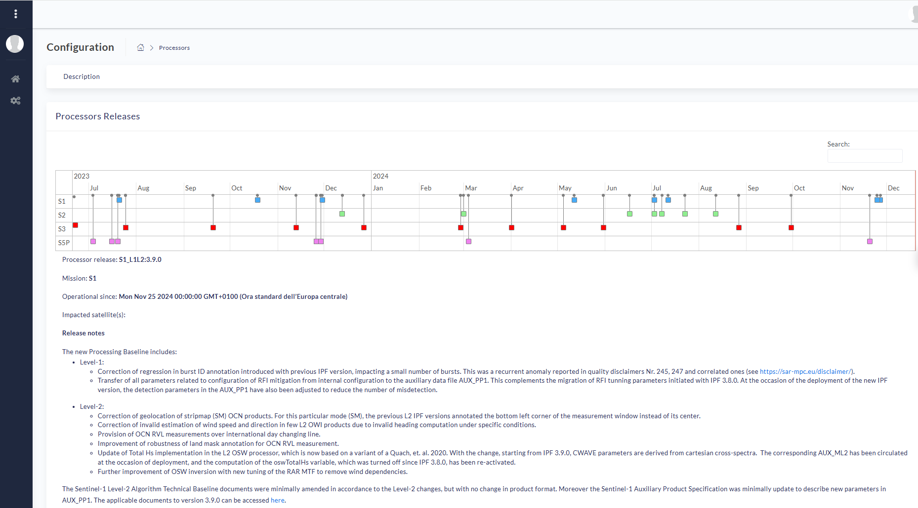
Figure 3-4 The Processors web page

